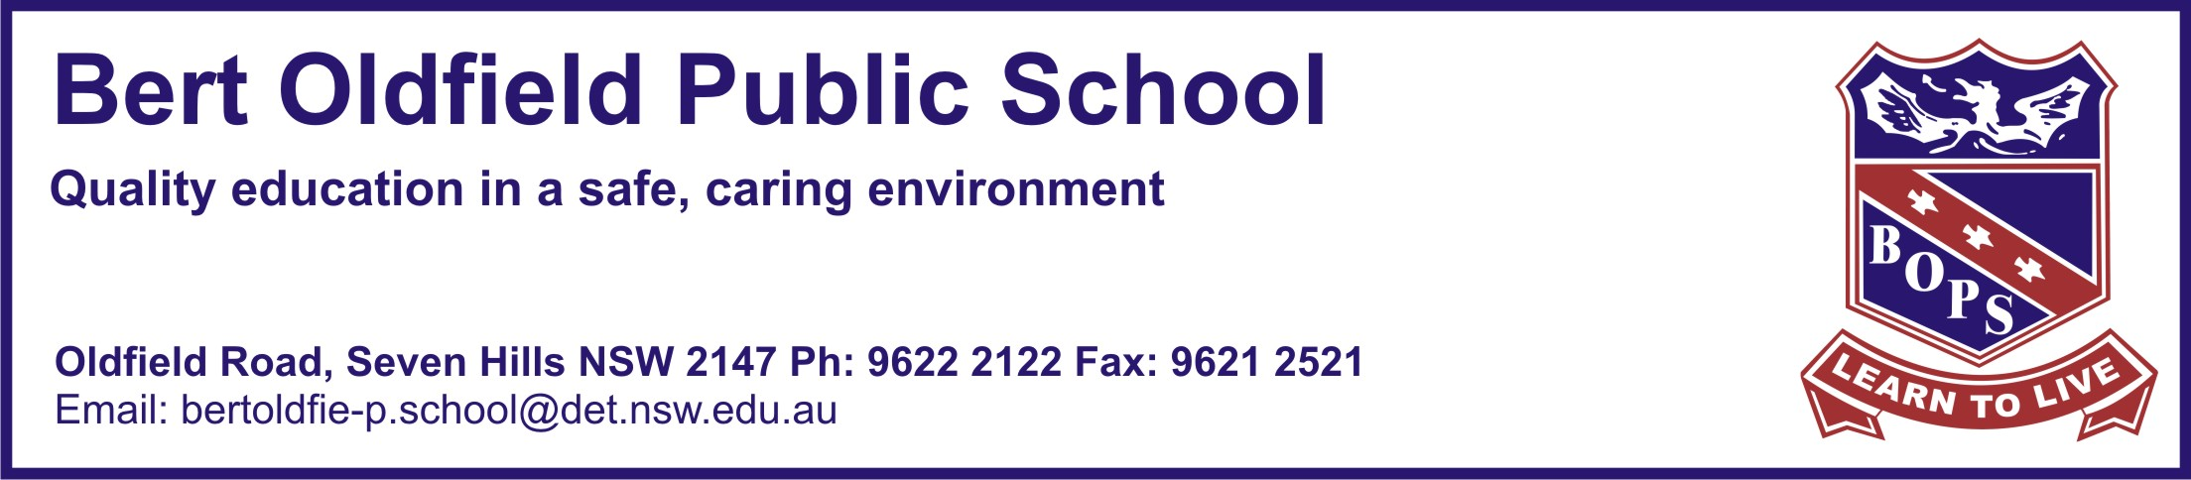
Friday15th May 2018
Life Education Program, 2018
Dear Parents and Caregivers,

An excursion has been organised for all children in Years K-6 to visit the Life Education Centre at Colyton, on the following dates;

Monday 4th June, Tuesday 5th June, Wednesday 6th June, Tuesday 12th June and Wednesday 13th June 2018.

This program helps children develop skills which enable them to make responsible decisions about themselves and their bodies. The children will participate in a program to promote a healthy lifestyle. Life Education is not a one-off experience as the program addresses many of the components and objectives within the NSW P.D.H.P.E Curriculum.

Set out below is a brief outline of the program contents that will be seen by the children.

Kindergarten | My Body Matters | Personal responsibility for being safe and healthy, identifying healthy food and habits, benefits of physical activity, identifying safe and unsafe behaviors, situations and environments.
K/1 | Harold’s Friend Ship | Maintaining positive relationships, identifying feelings and emotions, identifying safe people, places and situations.
Year 1  Year 2 | Growing Good Friends | Showing care and concern for each other, health and wellbeing in relation to positive friendships, identifying sage safe and unsafe behaviors.
Year 3  Year 4 | bCyberwise | Building positive online relationships, responsible use of technology, keeping personal information safe, dealing with bullying and cyberbullying, exploring the role of a bystander.
Year 5  Year 6 | Relate Respect Connect | Explores building positive, safe and respectful relationships. Understanding how to respect ourselves and others, identifying characteristics of positive relationships, strategies to help maintain positive online and offline relationships, strategies to respond to unsafe or disrespectful situations online and offline the importance of relationships to our own and others’ wellbeing.

Dates of visits: Monday 4th, Tuesday 5th Wednesday, 6th, Tuesday 12th and Wednesday 13th June 2018.
The Life Education Centre is not able to allocate specific days for each grade until numbers are finalised.

Cost: $10.00 per child

Transport: Bus is provided by the Life Education Centre

Please complete the tear off slip below and return it to the office by Friday, 22nd May 2018 together with $10.00,
in an envelope marked ‘Life Education’ and your child’s name clearly marked. If you are paying online, please return the tear
off slip below with your child’s name, class and your online payment receipt number.

Thank you for your cooperation,

Mrs Landall
Life Education Coordinator
__________________________________________________________________________________________________
Bert Oldfield Public School, Life Education Excursion 2018
I give permission for my child___________________________________ of class________ to attend the Life Education Program at the Colyton Centre. I understand that the excursion has the approval of the principal and travel to and from the Life Education Centre will be by bus. Enclosed, please find $10.00 being for payment of attendance at Life Education number.
My online payment receipt number is ___________________
Name: ____________________________ (Please print)
Signed: _____________________________________ (Parent/Guardian) Date:______________

